**BIODATA**

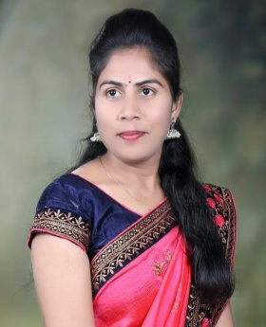

**Miss.Archana Gajanan Barabde**

* **Designation : Assistant Professor and Department of Economics**
* **College: Arts and Commerce College WarwatBakal, Dist.- Buldaha**
* E-mail :archanabarabde@gmail.com
* Cell No : 9529982942

**PERSONAL DETAILS:**

|  |  |
| --- | --- |
| **Educational Qualification** | **B.A, M.A.(Economics)** |
| **Department** | **Economics** |
| **Date of Birth** | **01 July 1998** |
| **Contact No.** | **9529982942** |

**EDUCATIONAL QUALIFICATION:**

|  |  |  |  |  |
| --- | --- | --- | --- | --- |
| **Sr. No.** | **Exam passed** | **Board/University** | **Year of passing** | **Percentage** |
| **1** | **S.S.C.** | **Amravati** | **2014** | **74.40%** |
| **2.** | **H.S.C.** | **Amravati** | **2016** | **68.15%** |
| **3** | **B.A.** | **SGBAU, Amravati** | **2019** | **50.33%** |
| **4.** | **M.A.** | **SGBAU, Amravati** | **2021** | **64.40%** |

Special Academic qualification :

1. **MS_CIT**

**Academic Experience:**

**SantGadge Baba Amravati University, Department of Economics :– Joined from 01/12/2022**

**Arts and Commerce College WarwatBakal :-- Joined from 01/12/2022**